**HEALTHCARE-ASSOCIATED INFECTIONS (HAIS)**

[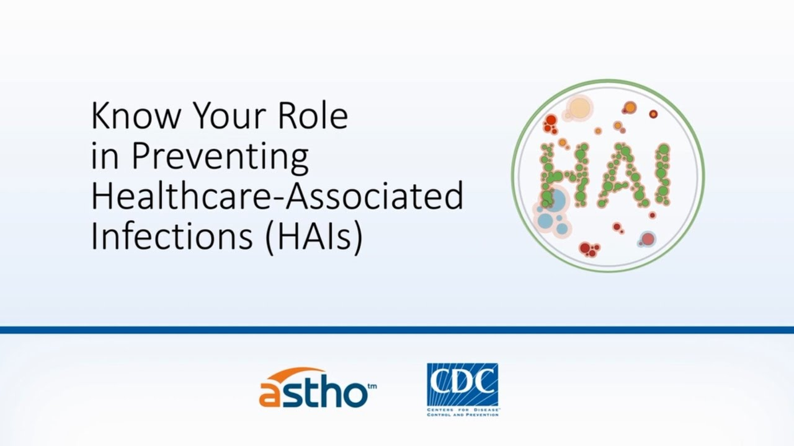](https://www.google.co.ke/url?sa=i&url=https%3A%2F%2Fwww.youtube.com%2Fwatch%3Fv%3DLFuq3mNHav8&psig=AOvVaw3ApcOK8enfaRiO9p9Uy77R&ust=1588618004015000&source=images&cd=vfe&ved=0CAIQjRxqFwoTCLDVsbetmOkCFQAAAAAdAAAAABAD)

**Goal**

1. Recognize person safety as an important healthcare provider’s responsibility in global healthcare system.
2. Explain the best practices of indwelling urinary catheter care.
3. Apply required knowledge in preventing and/or minimizing infection
4. Perform appropriate behaviours required to prevent Healthcare Associate Infections (HAIS)

**Introduction**

Healthcare Associate Infections (HAIS) are infections occurring in a person during the process of care in a hospital or other health care facility which was not present. These infections are not present at the time of admission or walk in. Transmission of organisms that cause HAIS can occur in many ways: caregiver-to-patient, environment-to-patient, or patient-to-patient.

[](https://www.google.co.ke/url?sa=i&url=https%3A%2F%2Fwww.webmd.com%2Fhealthy-aging%2Ffeatures%2Fwhat-to-expect-as-a-caregiver&psig=AOvVaw1hDOdugsz768z5jJZyweA9&ust=1588621344917000&source=images&cd=vfe&ved=0CAIQjRxqFwoTCPDimc-8mOkCFQAAAAAdAAAAABAD)

Many of these infections are preventable. Modern healthcare employs many types of invasive devices and procedures to treat patients and to help them recover. infections can be associated with procedures (like surgery) and the devices used in medical procedures, such as catheters. Those who access the health care system for illness or injury are expecting care and treatment, not additional illness and complications

HAIS occur in all types of care settings, including:

* Acute care hospitals
* Ambulatory surgical centers
* Dialysis facilities
* Outpatient care (e.g., physicians' offices and health care clinics)
* Long-term care facilities (e.g., nursing homes and rehabilitation facilities)

Common types of HAIS include:

* Catheter-associated urinary tract infections (CAUTI)-is the leading HAIS
* Surgical site infections
* Bloodstream infections
* Pneumonia
* Antibiotic-resistant organisms such as *clostridium difficile.*

C. difficile can cause severe damage to the colon and even be fatal.Symptoms include diarrhoea, stomach pain and fever. Treatment includes antibiotics. Even when treated with antibiotics, the infection may come back.

Traditionally, infection control in hospital focuses on hospital staff.Family attendants/caregivers too are integral to patient care. Family attendants/Caregivers who provide most of the hands-on care, provide bedside caregiving and all types of cleaning activities including cleaning urine, vomit, saliva and feces, and **potential infection-causing microbes.**

Prevention efforts must expand across the continuum of care and Challenges posed are best addressed through coordinated action among health care facilities and care providers.

**Why fuss about Healthcare-Associated Infections (HAIS)**

- Healthcare-associated infections (HAIS) can be serious and even deadly for patients.

- Implementing existing prevention practices can lead to up to a 70 percent reduction in certain HAIS.

- Treatment of HAIS can be difficult and may last for years, especially when the organism is resistant to multiple antibiotics.

-In addition to the human burden, excess costs are incurred across the health care system and many payors are no longer willing to accept these avoidable costs.

* 1. **Urinary Tract Infection (Catheter-Associated Urinary Tract Infection [CAUTI] and Non-Catheter-Associated Urinary Tract Infection [UTI])**

[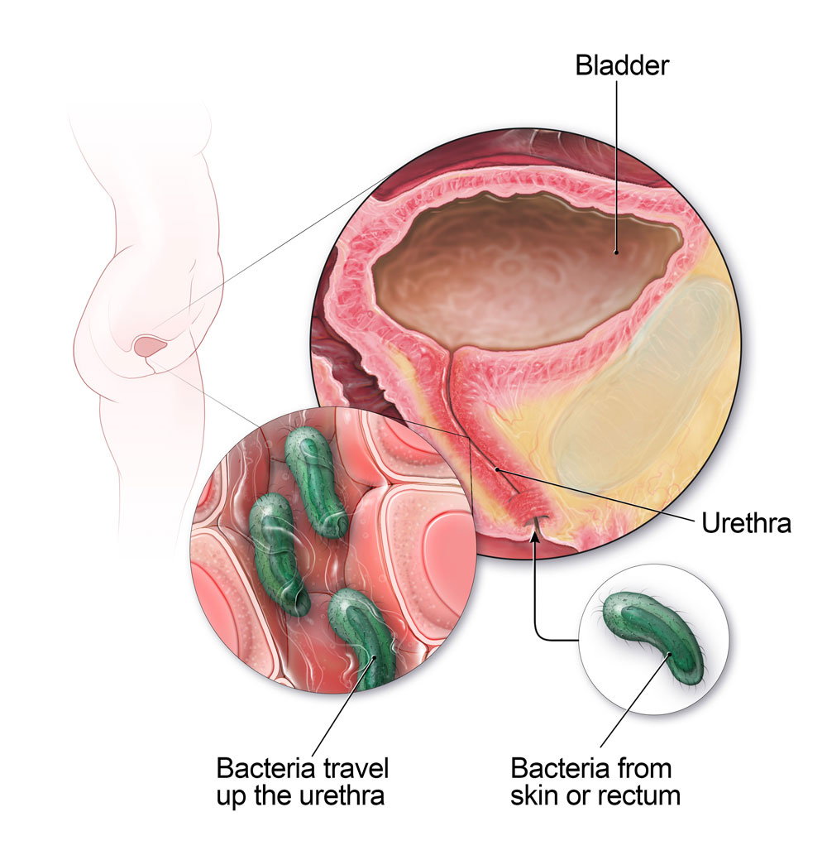](https://www.google.co.ke/url?sa=i&url=https%3A%2F%2Fwww.cdc.gov%2Fantibiotic-use%2Fcommunity%2Ffor-patients%2Fcommon-illnesses%2Futi.html&psig=AOvVaw1jTYC33pUzfKbKeGRjYz4U&ust=1588620943176000&source=images&cd=vfe&ved=0CAIQjRxqFwoTCKDm8624mOkCFQAAAAAdAAAAABAD)

A catheter-associated urinary tract infection (CAUTI) can occur when bacteria or other germs travel along a urinary catheter, resulting in an infection in the bladder or the kidney.

It is well known in the healthcare community that a catheter-associated urinary tract infection (CAUTI) is one of the most common infections a patient can contract in the hospital, accounting for 40% HAIS. Most common reason for inappropriate catheter use is incontinence. Patient or Family request is also responsible for inappropriately placed catheters.

This module describes key evidence-based care components for preventing catheter-associated urinary tract infections and describes how to implement these interventions.

* Approximately 12%-16% of adult hospital inpatients will have an indwelling urinary catheter (IUC) at some time during their hospitalization, and each day the indwelling urinary catheter remains, a patient has a 3%-7% increased risk of acquiring a catheter-associated urinary tract infection (CAUTI).
* CAUTI can lead to many complications.
* Complications associated with CAUTI cause discomfort to the patient, prolonged hospital stay, and increased cost and mortality.
* It has been estimated that each year, more than 13,000 deaths are associated with UTIs.

The type of catheter associated with CAUTI is indwelling catheter: A drainage tube that is inserted into the urinary bladder through the urethra, is left in place, and is connected to a drainage bag. These devices are also called Foley catheters. Condom or straight in-and-out catheters are not included.

[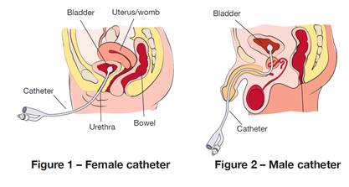](https://www.google.co.ke/url?sa=i&url=https%3A%2F%2Fhealthywa.wa.gov.au%2FArticles%2FU_Z%2FYour-indwelling-urinary-catheter&psig=AOvVaw3kqCWgEXx4VwD4YvIczew-&ust=1588516563922000&source=images&cd=vfe&ved=0CAIQjRxqFwoTCLCY48SzlekCFQAAAAAdAAAAABAD)

[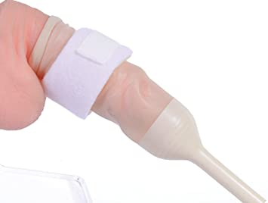](https://www.google.co.ke/url?sa=i&url=https%3A%2F%2Fwww.amazon.co.uk%2FExternal-Catheter-Extra-Fixer-Condom%2Fdp%2FB071P48C42&psig=AOvVaw0fG4Y_L5s0PUCEsAY9n6T4&ust=1588516610965000&source=images&cd=vfe&ved=0CAIQjRxqFwoTCLCT9tqzlekCFQAAAAAdAAAAABAJ)

Fig: Male external catheter condom catheter -is not included in Catheter associated urinary tract infections (CAUTI)

**CARE FOR RESIDENTS WITH CATHETERS**

**Evidence-based practices to prevent CAUTI and improve resident safety**

**FACTS**

1. Adherence to infection control principles through proper maintenance
2. Do not use the indwelling catheter unless you must!
3. Condom catheterization in male patients
4. Early removal of the catheter using reminders

[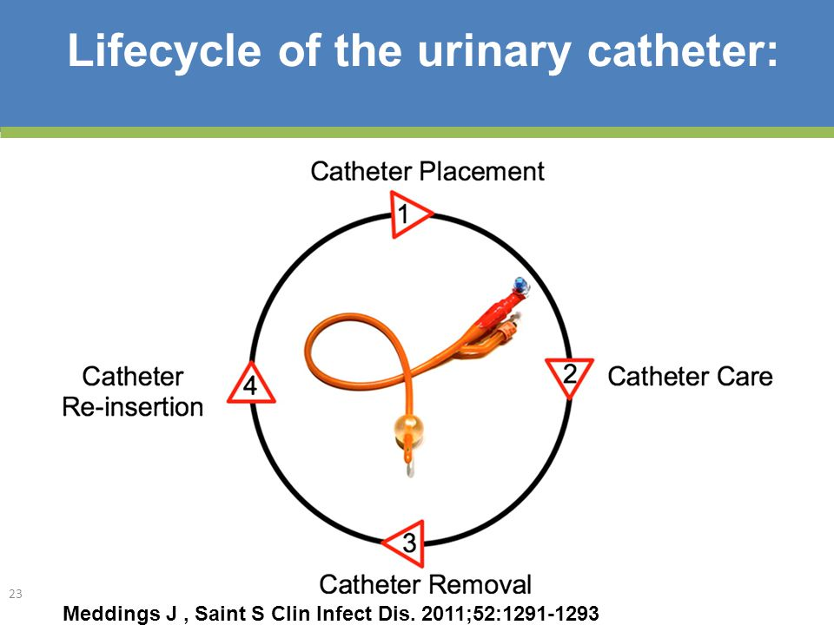](https://www.google.co.ke/url?sa=i&url=https%3A%2F%2Fslideplayer.com%2Fslide%2F5711874%2F&psig=AOvVaw2Ew5kDeLqKi1Jk_M4RfqiV&ust=1588520525223000&source=images&cd=vfe&ved=0CAIQjRxqFwoTCPDQx6HClekCFQAAAAAdAAAAABBc)

**Adherence to infection control principles through proper maintenance**

1. Only properly trained persons (e.g. health care provider, personnel, family members, or patients themselves) who know the correct technique of catheter maintenance are given this responsibility.
2. Use standard precautions i.e. Strict hand washing MUST be used before and after touching urinary catheter

[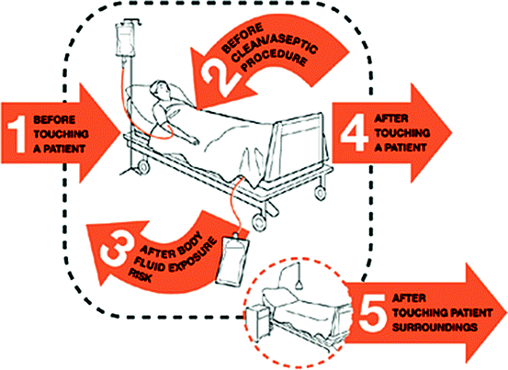](https://www.google.co.ke/url?sa=i&url=https%3A%2F%2Flink.springer.com%2Fchapter%2F10.1007%2F978-81-322-0535-7_48&psig=AOvVaw0GrqXy6E1wF3buDch-aAtT&ust=1588619157662000&source=images&cd=vfe&ved=0CAIQjRxqFwoTCJChq9mxmOkCFQAAAAAdAAAAABAa)

1. Perform perineal care: daily hygiene and after each bowel movement (long call) and cleansing of insertion site (meatus/urethral opening) using soap and water is appropriate. Should NOT cleaned vigorously or with antiseptic solutions. It reduces potential for infections to pass up of the catheter

[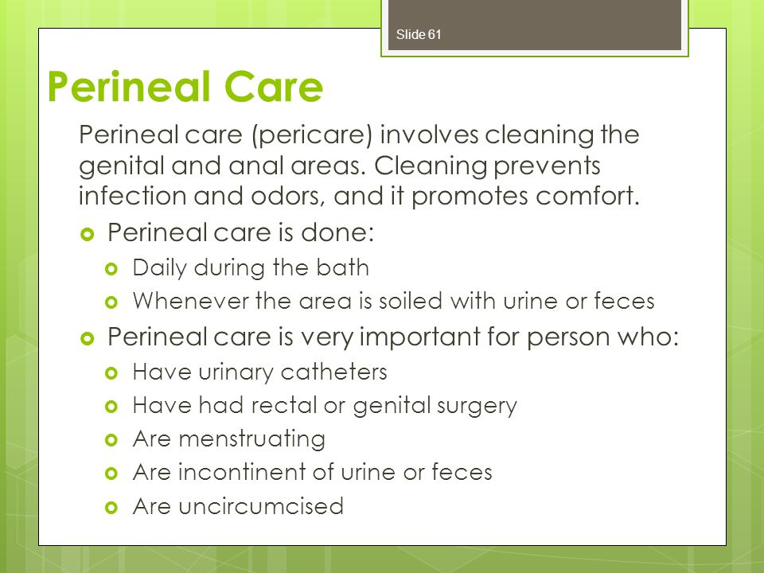](https://www.google.co.ke/url?sa=i&url=https%3A%2F%2Fslideplayer.com%2Fslide%2F7548601%2F&psig=AOvVaw390QFjNlCAnriwCJY4khyd&ust=1588619296790000&source=images&cd=vfe&ved=0CAIQjRxqFwoTCNi21pmymOkCFQAAAAAdAAAAABAJ)

[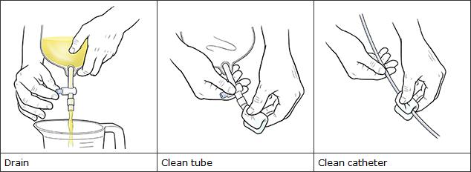](https://www.google.co.ke/url?sa=i&url=https%3A%2F%2Fwww.mountnittany.org%2Farticles%2Fhealthsheets%2F3334&psig=AOvVaw3nYwuPxBWfeuWxPXH-s8Gn&ust=1588619954375000&source=images&cd=vfe&ved=0CAIQjRxqFwoTCPDP-de0mOkCFQAAAAAdAAAAABAD)

1. Drainage bag must always be kept lower than patient’s bladder, including during transport and other activity.

[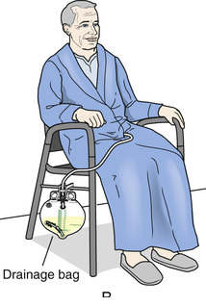](https://www.google.co.ke/url?sa=i&url=https%3A%2F%2Fwww.clipart1001.com%2Ffoley-catheter-clipart-bag-ized%2F&psig=AOvVaw3A--n1_z7bMwm8pkTTqimf&ust=1588618355006000&source=images&cd=vfe&ved=0CAIQjRxqFwoTCLjrid-umOkCFQAAAAAdAAAAABAI)

[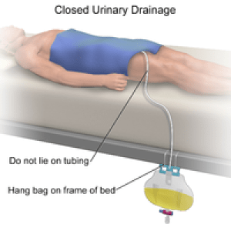](https://www.google.co.ke/url?sa=i&url=https%3A%2F%2Fwww.jaga-me.com%2Fcaregivers-guide-urinary-catheter%2F&psig=AOvVaw3zsXct8SDrxGPXgTDVXs5e&ust=1588619612816000&source=images&cd=vfe&ved=0CAIQjRxqFwoTCNDmzbmzmOkCFQAAAAAdAAAAABAJ)

1. Secure the catheter with a leg strap or tube holder with nonslip loop to decrease movement and tension on the urethra

[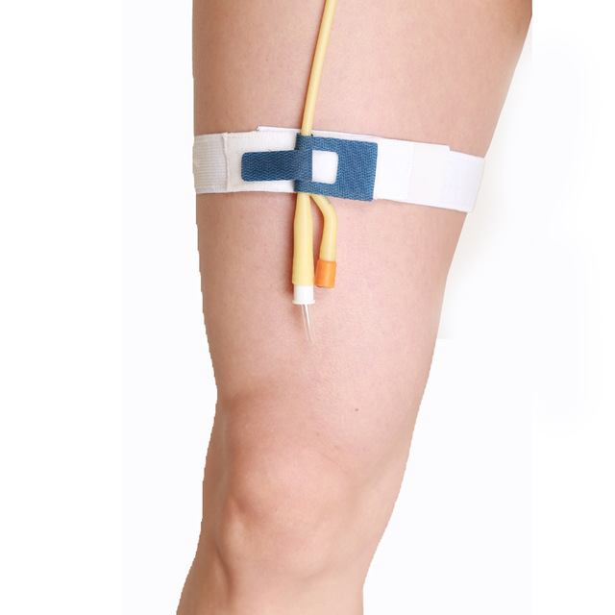](https://www.google.co.ke/url?sa=i&url=https%3A%2F%2Fwww.alibaba.com%2Fproduct-detail%2FCryo-push-medical-consumables-foley-catheter_60659787939.html&psig=AOvVaw2cCtxlt5HiIdOE-qK9UCbF&ust=1588619484548000&source=images&cd=vfe&ved=0CAIQjRxqFwoTCNj6w_mymOkCFQAAAAAdAAAAABAD)

1. A catheter bag stand must always be used. The bag should be placed lower than the bladder but have no contact with the floor.

[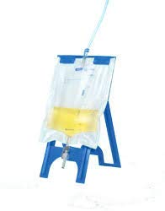](https://www.google.co.ke/url?sa=i&url=https%3A%2F%2Fwww.amazon.co.uk%2FSimpla-Bed-Stand-Urine-Holder%2Fdp%2FB07N6MD8JH&psig=AOvVaw1TNCKBFmjvpi7D5Zd9Ejyg&ust=1588619039554000&source=images&cd=vfe&ved=0CAIQjRxqFwoTCID3tKixmOkCFQAAAAAdAAAAABAD)

Image: Bed bag stand

1. Keep the catheter and all tubing from kinking/obstruction. Ensure smooth flow of urine.
2. Make sure you do not contaminate catheter outlet valve when emptying the collection bag.
3. Avoid allowing the drainage spigot to touch the collecting container, floor, or toilet.
4. A clean receptacle must be used every time a catheter is emptied
5. If any disconnection of tubing or bag leakage, report immediately

[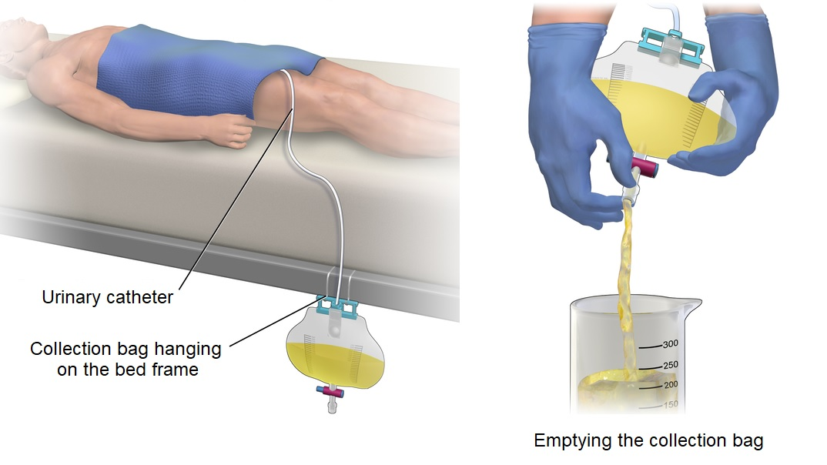](https://www.google.co.ke/url?sa=i&url=https%3A%2F%2Fscireproject.com%2Fcommunity%2Ftopic%2Furinary-catheters%2F&psig=AOvVaw3zsXct8SDrxGPXgTDVXs5e&ust=1588619612816000&source=images&cd=vfe&ved=0CAIQjRxqFwoTCNDmzbmzmOkCFQAAAAAdAAAAABAV)

[](https://www.google.co.ke/url?sa=i&url=https%3A%2F%2Fwww.gettyimages.com%2Fdetail%2Fphoto%2Fnurse-emptying-a-catheter-bag-high-res-stock-photography%2F626727350&psig=AOvVaw2Yx2vgW2KP7AsKT1uqPvTe&ust=1588524113916000&source=images&cd=vfe&ved=0CAIQjRxqFwoTCIiJhM_PlekCFQAAAAAdAAAAABBK)

**Additional measures**

* Use of urinary catheters in patients and nursing home residents for **management** of incontinence should be avoided

[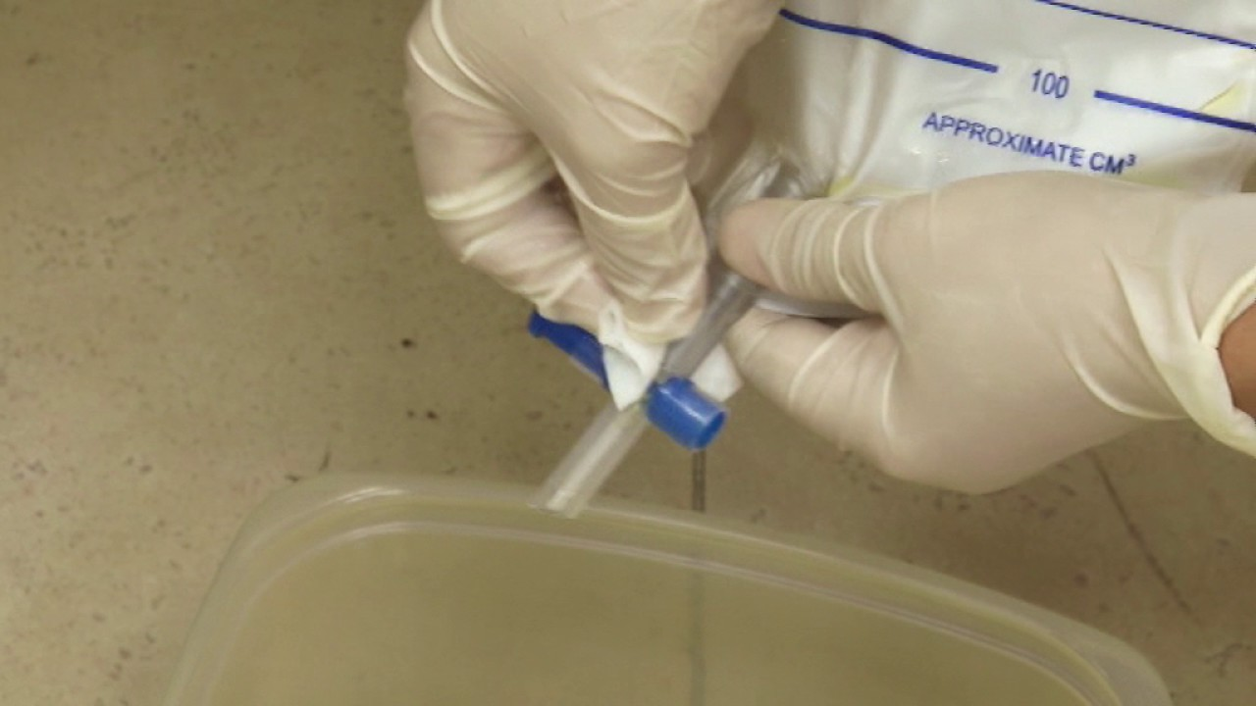](https://www.google.co.ke/url?sa=i&url=https%3A%2F%2Fwww.youtube.com%2Fwatch%3Fv%3DsHrusG0b2tg&psig=AOvVaw2Yx2vgW2KP7AsKT1uqPvTe&ust=1588524113916000&source=images&cd=vfe&ved=0CAIQjRxqFwoTCIiJhM_PlekCFQAAAAAdAAAAABBU)

[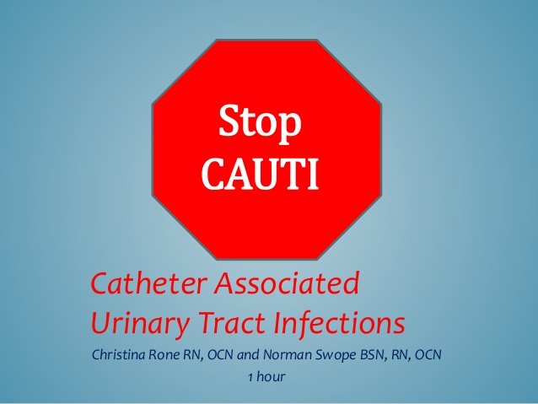](https://www.google.co.ke/url?sa=i&url=https%3A%2F%2Fwww.slideshare.net%2FNormanSwope1%2Fstop-cauti&psig=AOvVaw1fZaBX1jEahYSiCMOwEc8B&ust=1588518248917000&source=images&cd=vfe&ved=0CAIQjRxqFwoTCPj46fa5lekCFQAAAAAdAAAAABAD)

**2. SURGICAL SITE INFECTIONS**

**Goal**

- To keep the surgical site clean and dry

Surgical site infections (SSIs) continue to constitute a major challenge to healthcare institutions as a leading cause of healthcare associated infections (HAIs)

There are various factors contributing to the risk of SSI occurrence and preventative measures require an integrative approach that focuses through the pre-, intra- and postoperative care involving all the stakeholders.

[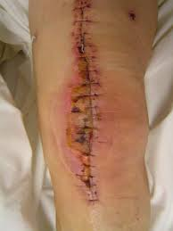](https://www.google.com/url?sa=i&url=http%3A%2F%2Fwww.aado.org%2Ffile%2Fpssi-ws_oct10%2F06_Management.pdf&psig=AOvVaw0NKomHdPvF-yoYi4WnaCTI&ust=1588676817693000&source=images&cd=vfe&ved=0CAIQjRxqFwoTCKi1kL2ImukCFQAAAAAdAAAAABAJ)

**Wound care after surgery**

1. Ask the doctor how long the surgical site should be kept dry. Follow the doctor's instructions.

[](https://www.google.com/url?sa=i&url=https%3A%2F%2Fwww.bloomyourhealth.com%2Fa-cosmetic-journey-6-tips-for-a-fast-plastic-surgery-recovery%2F&psig=AOvVaw1jtG8ScHSZJGRKgENma2Z1&ust=1588676871018000&source=images&cd=vfe&ved=0CAIQjRxqFwoTCJC849mImukCFQAAAAAdAAAAABAD)

1. Look at the incision every day, checking for signs of infection
2. If there is excess wound leakage and a change of dressing is necessary, this should be done under a clean technique (aseptic technique- **Aseptic technique** means using practices and procedures to prevent contamination from pathogens. It involves applying the strictest rules to minimize the risk of infection.). Otherwise, any microorganisms nearby can become a source of infection

[](https://www.google.com/url?sa=i&url=https%3A%2F%2Fwww.lifespan.org%2Fcenters-services%2Fwound-care-and-hyperbaric-medicine&psig=AOvVaw0qcb_B5rt3v3ukB4mDeSMr&ust=1588677238800000&source=images&cd=vfe&ved=0CAIQjRxqFwoTCNi_r46KmukCFQAAAAAdAAAAABAJ)

1. Ensure you perform hand hygiene and put gloves on immediately before changing the dressing.
2. Visitors should not touch the wound or the dressing when visiting. If they need to help, they need to follow the mentioned infection prevention measures.
3. If any symptoms of wound infection are present (redness, pain, swelling, fever) inform the doctor or nurse.

Do **not**:

* Scrub or rub incisions.
* Remove the tape strips from incisions.
* Use lotion or powder on incisions.
* Expose incisions to sunlight.
* Offer a full bath unless you can keep the incision dry. Instead, take showers or sponge baths until the doctor says it is okay to take baths. Before showering, cover the dressing with a plastic bag or use another method of keeping it dry.

**Note:** Soreness, tenderness, tingling, numbness, itching around the incision, mild oozing and bruising, and a small lump may form is normal and no cause for concern.

**Call the doctor** if you notice signs of an infection, such as:

* A yellow or green discharge that is increasing.
* A change in the odor of the discharge.
* A change in the size of the incision.
* Redness or hardening of the surrounding area.
* The incision is hot to the touch.
* [Fever](https://www.uofmhealth.org/health-library/not48628#not48628-sec).
* Increasing or unusual pain.
* Excessive bleeding that has soaked through the dressing.

**Changing a dressing**

Before you start, make sure you have gauze pads, a box of medical gloves, surgical tape, a plastic bag, and scissors.

[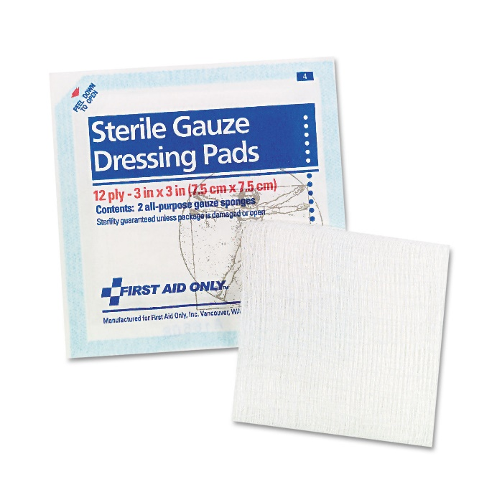](https://www.google.com/url?sa=i&url=https%3A%2F%2Fwww.ontimesupplies.com%2Ffaofae5005-smartcompliance-gauze-pads-3-x-3-5-pack.html&psig=AOvVaw0Q7JAWTLCna266dXq-J3V5&ust=1588677663970000&source=images&cd=vfe&ved=0CAIQjRxqFwoTCNigjtGLmukCFQAAAAAdAAAAABAD)[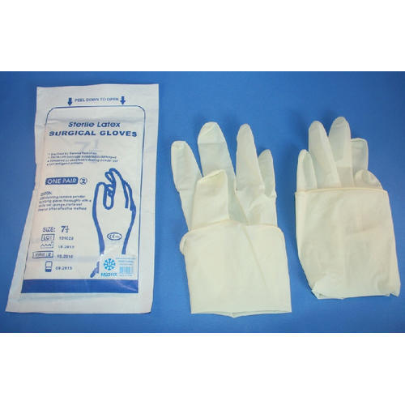](https://www.google.com/url?sa=i&url=https%3A%2F%2Fwww.indiamart.com%2Fproddetail%2Fsterile-latex-surgical-gloves-14464915188.html&psig=AOvVaw1kczOnJ6pNlOZuD49o_-xW&ust=1588677721220000&source=images&cd=vfe&ved=0CAIQjRxqFwoTCKjb_-yLmukCFQAAAAAdAAAAABAD) [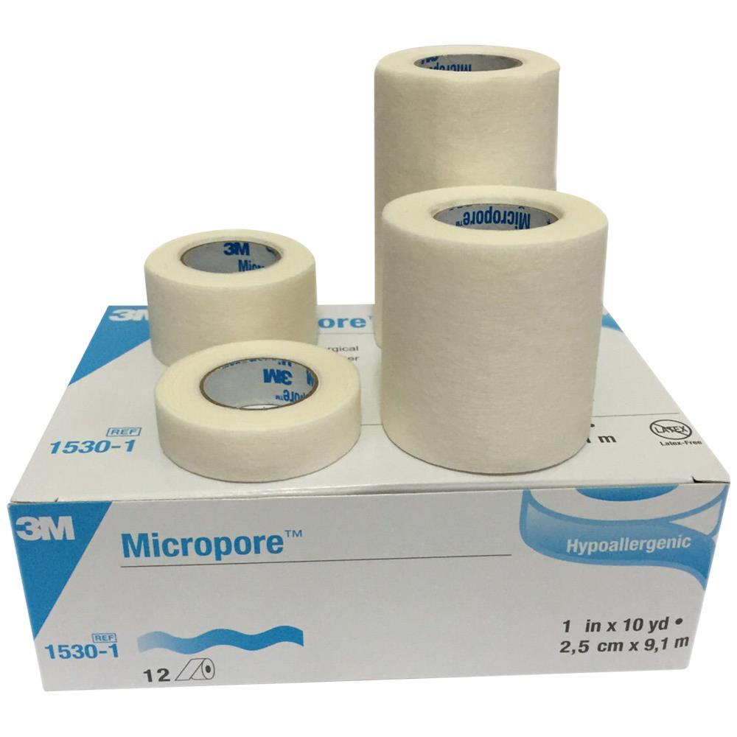](https://www.google.com/url?sa=i&url=https%3A%2F%2Fwww.healthproductsforyou.com%2Fp-a3m-micropore-surgical-white-paper-tape.html&psig=AOvVaw2BZVw9sihcy92R9UyHG5P2&ust=1588677821410000&source=images&cd=vfe&ved=0CAIQjRxqFwoTCJDflJ6MmukCFQAAAAAdAAAAABAD)

Then:

1. Prepare supplies by opening the gauze packages and cutting new tape strips.
2. [Wash and dry your hands](https://www.uofmhealth.org/health-library/tv7076spec#tp21202). Put on medical gloves.
3. Loosen the tape around the old dressing.
4. Remove the old dressing.
5. Clean the incision if allowed by the doctor to dress.
6. Inspect the incision for signs of infection.
7. Hold a clean, sterile gauze pad by the corner and place over the incision.
8. Tape all four sides of the gauze pad.
9. Put all trash in a plastic bag. Remove your gloves last.
10. Seal plastic bag and throw it away.
11. Wash your hands.

**Cleaning an incision**

To clean the incision:

* Gently wash it the recommended solutions
* Do not scrub
* Reapply a clean dressing.

[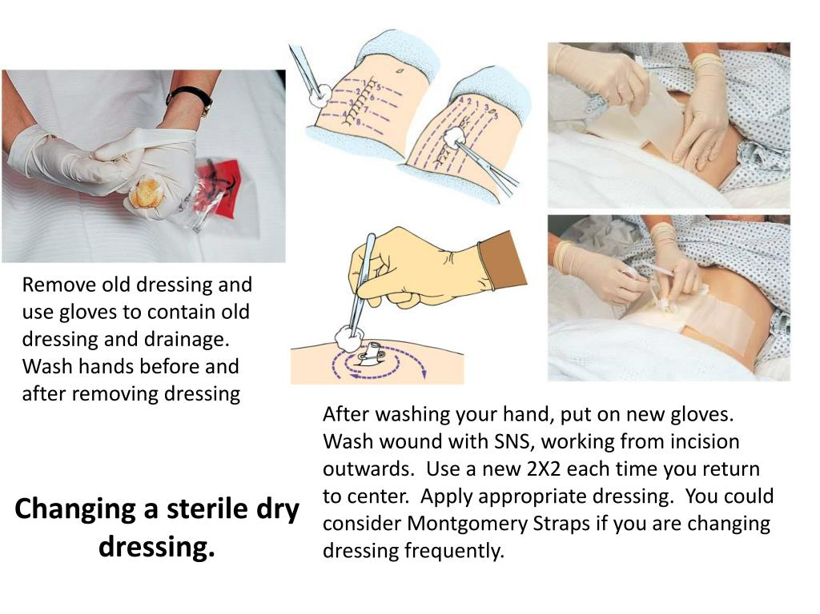](https://www.google.com/url?sa=i&url=https%3A%2F%2Fwww.slideserve.com%2Fkorene%2Fsurgical-wound-care&psig=AOvVaw3jao8jEKCO9dpsKIRFHzP0&ust=1588677446883000&source=images&cd=vfe&ved=0CAIQjRxqFwoTCICSie2KmukCFQAAAAAdAAAAABAD)

**Caring for stitches, staples, tissue glue, or adhesive strips**

Stitches or staples normally cause some redness and swelling where the stitch enters the skin, along with mild irritation and itching. Some drainage (clear/sticky oozy discharge) from the incision may be expected for the first few days after surgery. But if the discharge does not decrease after a few days, becomes bright red with blood, or contains pus, contact your doctor.

The incisions may be protected with tissue glue or small adhesive strips (such as Steri-Strips) instead of a dressing or bandage. If glue was used, be sure to dry the incision area right away if it gets wet. The glue will fall off on its own after a bit of time. If adhesive strips were used, leave them in place until they become loose or fall off on their own.

### Other incision care tips

After some surgeries, are given other than these for taking care of the incision.

* Be sure to follow those instructions carefully. If you are confused by the instructions or you have a question, call your doctor's office. If the office is closed, leave a message with the answering service.
* If the pain has increased or you suspect an infection, call the doctor as soon as possible.
* Do not expose the incision to direct sun for 3 to 9 months after surgery.
* As an incision heals, the new skin that is formed over the cut is very sensitive to sunlight and will burn more easily than normal skin.
* Bad scarring could occur if sunburn gets on this new skin.

[](https://www.google.co.ke/url?sa=i&url=https%3A%2F%2Fwww.chthealthcare.com%2Fblog%2Fnosocomial-infections&psig=AOvVaw1ezQD-IaqRzdu9Eez5VmZ3&ust=1588623056506000&source=images&cd=vfe&ved=0CAIQjRxqFwoTCIjhg6DAmOkCFQAAAAAdAAAAABAD)